 Course title and number:

420-DW3-AS Web Server Application Development I

**LAB 1**

Essential content to be covered –

Vocabulary of PHP

Indications

1. Submit the code of your program (.php files).
2. Submit this form with corresponding screenshots (more than one when applicable) below each exercise that prove you create the appropriate program and it works.

----------------------------------------------

**Exercise 1 –**

Access the html document below to see its result with a Web browser and modify it as follows:

1. In the second table row (tr), display the word “Blue” with PHP (PHP embedded in HTML), like this : echo 'Blue';
2. In the second table row (tr), display the value of the property background-color “#0000ff'” with PHP (PHP embedded in HTML), like this : echo '#0000ff';
3. Display the third table row (tr) with PHP (PHP embedded in HTML), like this :
   1. Display each single line of code

For example: echo " <td><h2>Green</h2></td>\n";

* 1. Use the escape character \ to keep the “double quotes” of the HTML attributes inside the main beginning and closing “double quotes” of the command “echo”.

For example: style=\"width:63px; background-color:#008000\"

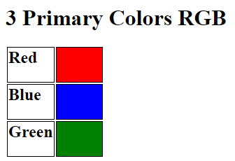

<!DOCTYPE html>

<html>

  <head>

    <style>

      td {

        border: solid 1px #000000;

      }

    </style>

  </head>

  <body>

    <h1>3 Primary Colors RGB</h2>

    <table>

      <tr>

        <td><h2>Red</h2></td>

        <td style="width:63px; background-color:#ff0000;"></td>

      </tr>

      <tr>

        <td><h2>Blue</h2></td>

        <td style="width:63px; background-color:#0000ff;"></td>

      </tr>

      <tr>

        <td><h2>Green</h2></td>

        <td style="width:63px; background-color:#008000;"></td>

      </tr>

    </table>

  </body>

</html>

**Exercise 2 –**

Modify the html document given in the previous Exercise 1 as follows:

* Use the Heredoc Operator to convert the HTML Body Element (whole content located within the tag body) to PHP like this:

echo <<<_END

          <h1>3 Primary Colors RGB</h2>

          <table>

.

.

.

</tr>

          </table>

        _END;